**DAILY ONLINE ACTIVITIES SUMMARY**

|  |  |  |  |  |  |  |  |  |
| --- | --- | --- | --- | --- | --- | --- | --- | --- |
| **Date:** | 03/07/2020 | | | | | **Name:** | RIYA CP | |
| **Sem & Sec** | IV sem & B section | | | | | **USN:** | 4AL18CS070 | |
| **Online Test Summary** | | | | | | | | |
| **Subject** | | **-** | | | | | | |
| **Max. Marks** | | 30 | | **Score** | | | **-** | |
| **Certification Course Summary** | | | | | | | | |
| **Course** | Introduction to Productive Modelling and Analytics | | | | | | | |
| **Certificate Provider** | | | Greatlearning academy | | **Duration** | | | 5.5hours |
| **Coding Challenges** | | | | | | | | |
| **Problem Statement1:** - | | | | | | | | |
| **Status: -** | | | | | | | | |
| **Uploaded the report in Github** | | | | | **-** | | | |
| **If yes Repository name** | | | | | **-** | | | |
| **Uploaded the report in slack** | | | | | **-** | | | |

**Online Test Summary:** No internals conducted today.

**Online Certification Course Summary:** Today I have opted the new course named Introduction to Productive Modelling and Analytics which belongs to Data Science Stream. In today’s session I have learnt what is Productive Modelling.

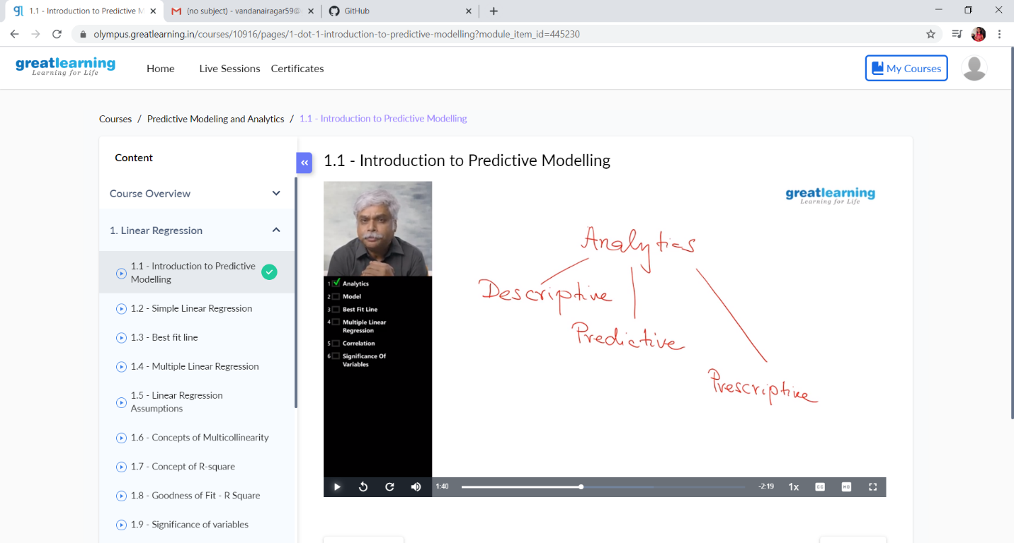

This is the Snapshot of today’s session.

**Online Coding Summary:** No problem Statements given.

**Online Training:** Todays was session 3 on C Programming by Megha Hegde Ma’am at 2:30pm to 4pm and quiz was conducted after the session

